Trial Installation Notes (Java)

- Download
Download the installer from http://www.easyxls.com/trials

- Run
Execute the installer file (for Windows double-click on EasyXLS_Trial_for_Java.exe to run the installer).

- Welcome
The installer will display the Welcome screen.
Press the Next button to continue the installing process.

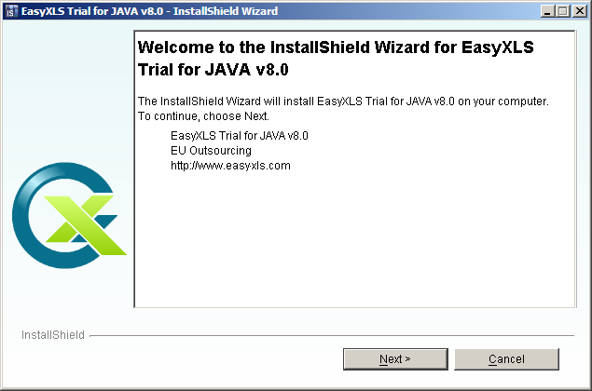

- License agreement
Read the license agreement carefully. Select “I accept the terms of the license agreement” radio button if you agree with it.
Press Next button.

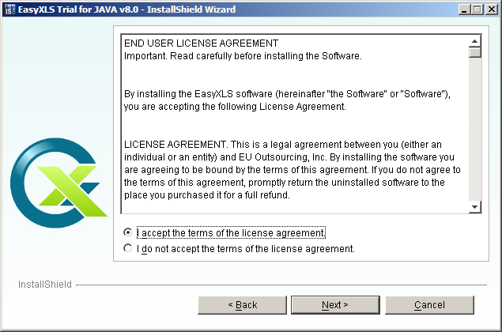

- Register
Enter personal information:
  - User Name: your name
  - Company Name: your company name
Press Next button.

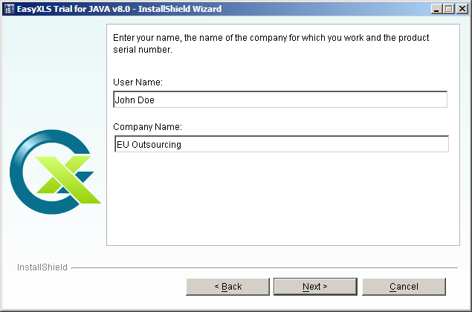

- Certify
Enter the requested information to certify yourself:
  - Certified Name: your name
  - Email: your email
  - Select the checkbox if you want to receive information on EasyXLS software products
Press Next button.

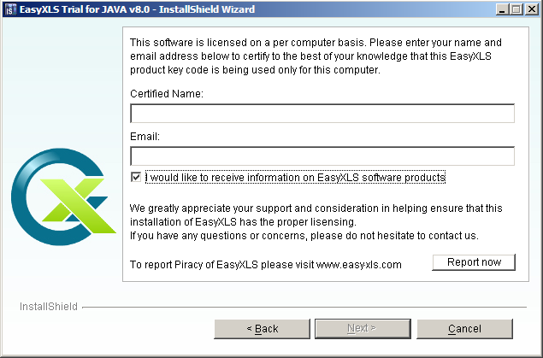

7. Destination Folder
This screen will allow you to choose the installation destination. Click on ”Browse” button to select the destination folder.
Press Next button.

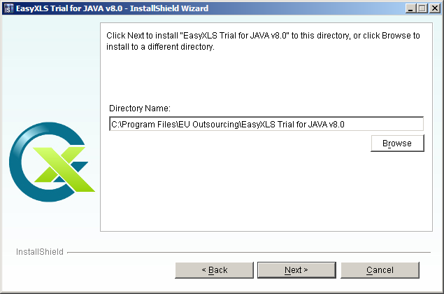

- Setup Type
Select the setup type that best suits you:
  - Typical: JAR library, Documentation and Tutorials will be installed. Go to Step 10 (Ready install).
  - Custom: if you want to select the features to be installed
Press Next button.

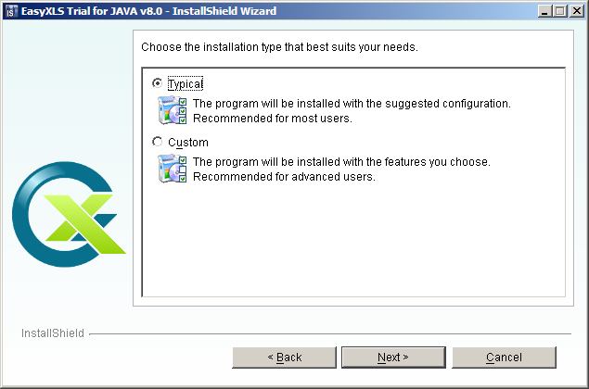

- Select features
Select the features you want to install and deselect the features you don’t want to install.
Press Next button.

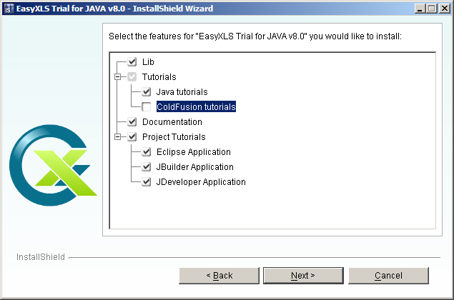

- Ready install
EasyXLS is ready to be installed.
Press Install button.

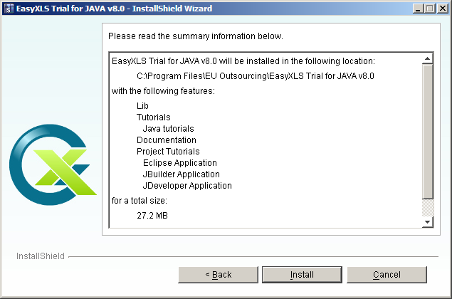

- Installation
Please wait to complete the installation.

- Finish
The installation is completed.
Press Finish button.

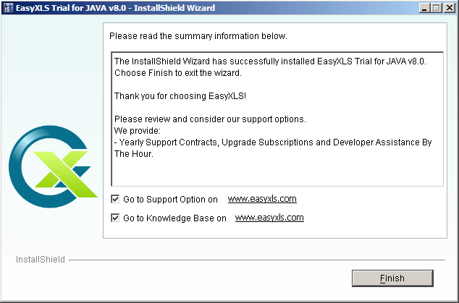
- Read me
ReadMe.txt is displayed. The file contains your trial license key and a license agreement.

